Prehistoric tales and cave paintings
In 1980, Jean Auel wrote the first of the Earth’s Children series, “The Clan of the Cave Bear”, as a story of the Cro-Magnon and Neanderthal peoples. When I read it, I was instantly drawn into the story of Ayla, the Cro-Magnon orphan, adopted by a Neanderthal tribe. Ayla became an inspiration, and fueled my interest into pre-history, cave paintings, and ancient burial rites.
When I had the chance to visit Spain, in 1990, I took the opportunity to visit Nerja, in the province of Malaga. Malaga had fiestas, bullfights, great food. Nearby Grenada has the amazing Alhambra palace. Nerja, with its sunny beaches, delicious food is a haven for tourists. Yet to me its most attractive feature was the caves with their cave paintings, their burial chambers.

Nerja, Province of Málaga, Spain
NERJA
Approximately 5 million years ago, during the Upper Miocene, water penetrated the fissures of the marble rock and dissolved it, forming a huge subterranean cavern. Seismic movement and landslides during the Holocene forced the water to find new pathways through the cave system and began the formation of the giant stalactites and stalagmites that can be seen in the cave.

Skeletal remains found in the caverns indicate that they were inhabited from about 25,000 BC up until the Bronze Age. Cave paintings from the Paleolithic and post-Paleolithic eras have been discovered on the walls of the cave. For about 4,000 years from 25,000 BC the caves were used seasonally by a small group of humans. By 21,000 BC the human population had taken up year-round residence in the caves and had increased in number. A culture based on hunting in the local area had evolved, illustrated by cave paintings found in the cave which date to around the time. Parts of the cave were being used as a burial chamber.

When my cousin, Santuda, proposed a trip to Bhimbhetka, I was delighted.
The Caves of Bhimbhetka

Bhimbhetka is near Bhopal, at the foothills of the Vindhya mountains.

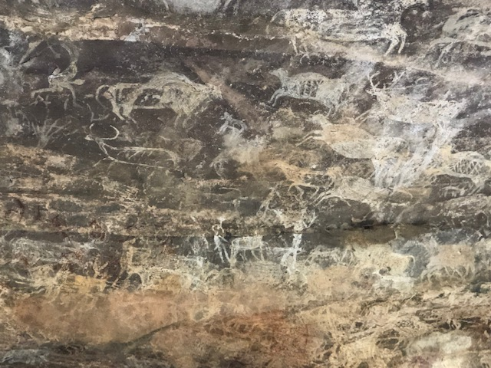

These caves were dwellings in prehistory. One of the caves was like an amphitheater, large, with a high painted ceiling.
We can clearly see the herds of horned animals.
Prehistoric painters used the pigments available in the vicinity. These pigments were earth pigments, red ochre, yellow ochre and umber, white from grounded calcite (lime).
Ochre consists of silica and clay and owes its color to iron oxide. It is found throughout the world, in many shades, in hues from yellow to brown, and faint blue. Chipped stone or bone tools were used as paintbrushes to apply the paint. The iron oxide-rich ochre rocks were ground to a fine powder and mixed with water or urine to form a paste. There is also evidence that early humans concocted a Stone Age super glue from mixing ochre with the gum of Acacia trees. Certainly the paintings have endured for thousands of years.
Umber is another natural brown or reddish-brown earth pigment that contains iron oxide and manganese oxide. Umber is darker than the other similar earth pigment, ochre. In its natural form, it is called raw umber. When heated (calcinated), the color becomes more intense, and then becomes known as burnt umber.
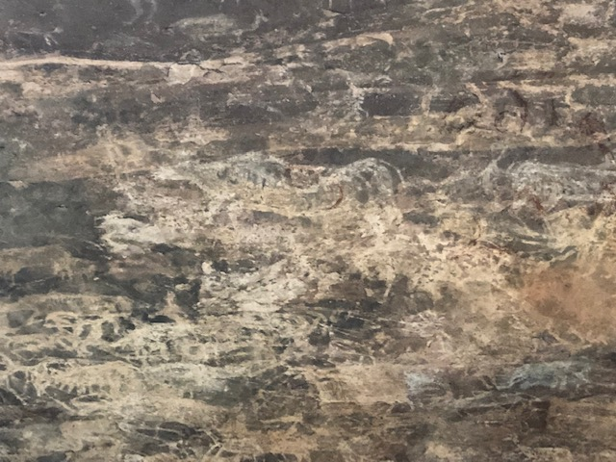

Some of the cave dwellers were artists who painted scenes from their daily lives on the cave walls.

The people who sheltered there were hunters.
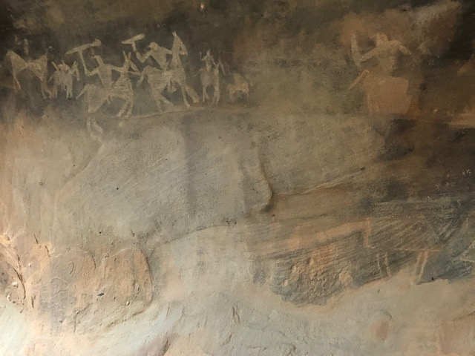

They also held celebrations and danced together. Maybe to celebrate a successful hunt? Unfortunately it was getting dark and I was unable to photograph that painting So I downloaded the same from Aunty Google!
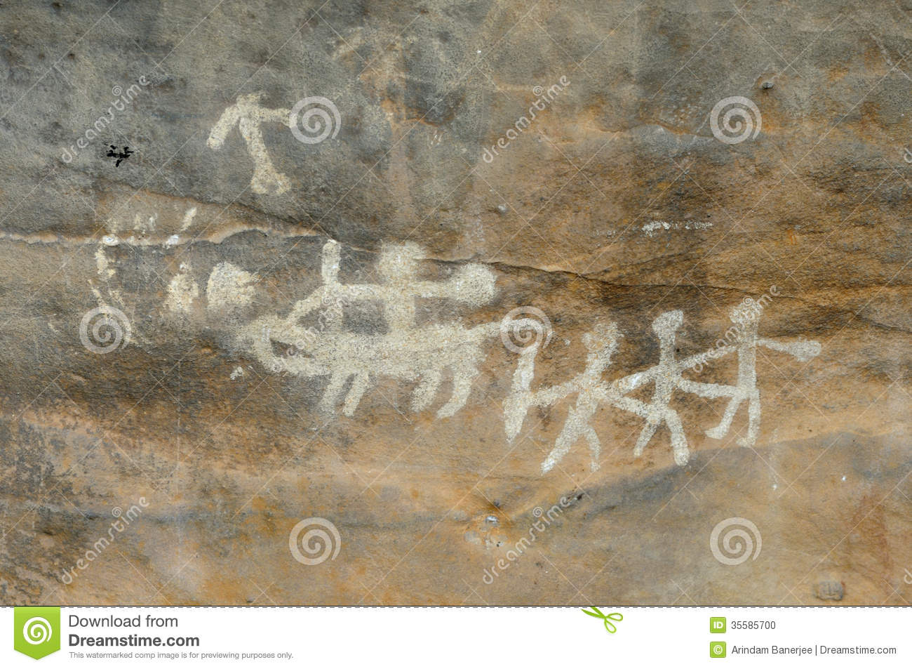

When (and if) you go to visit a cave – not just Bhimbhetka – make sure you wear laced up shoes with sturdy soles. I was wearing pumps with rubber soles, which were ok, except when I was scrambling up a rock or jumping down from one.

Altogether the caves were amazing, and I left feeling a great respect for those ancient cave people.
An aside before I leave, why is it called Bhimbhetka? Well, we know Bhim is giant strongman of the Pandava brothers from the epic Mahabharata. These caves are large enough for him to use as a sitting room. You can imagine him sitting there, and inviting you to join him, pointing out the paintings in which he is hunting or dancing with great vim and vigor. (Yes, Bhim and Vim mean the same thing. You can look up the etymology too.)

Thanks again, Santuda, for making this trip possible!

